Natural Shape Words – Pictures (1 of 3)

**1. Acicular // Needle shaped**

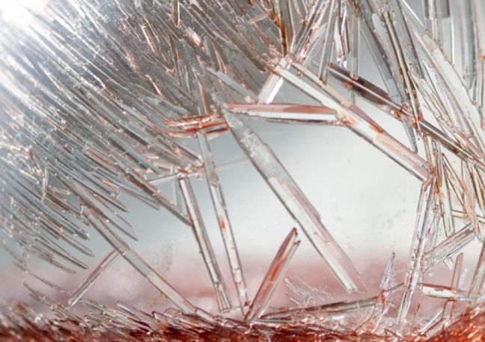

**2. Acetabuliform // Saucer shaped**

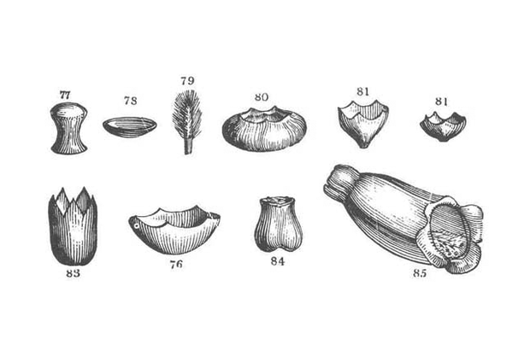

**3. Anguilliform // Eel shaped**

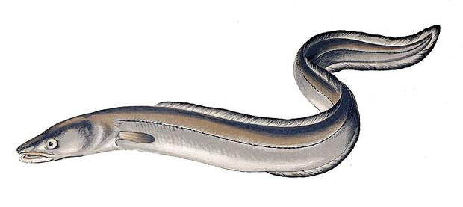

**4. Calceiform // Slipper shaped**

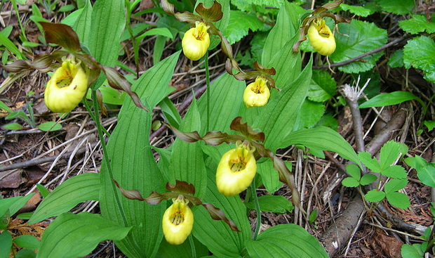

**5. Clithridiate // Keyhole shaped**



**6. Cochleate // Snail shaped**

